**Task: 4**

**🚀 Project Title: GitHub + Jenkins CI/CD Automation**

👨‍💻 **Intern Name:** *Ujjawal Rawat*  
📅 **Date:** 06 October 2025

**🌟 Objective**

To automate the build and deployment process using **Jenkins**, integrated with **GitHub Webhooks**, so every code push automatically triggers a pipeline to build and deploy the latest version — following true **CI/CD (Continuous Integration / Continuous Deployment)** principles.

**⚙️ Tools & Technologies**

| **Tool** | **Purpose** |
| --- | --- |
| ☁️ **AWS EC2 (Ubuntu)** | Hosting Jenkins Server |
| ⚙️ **Jenkins** | CI/CD Automation |
| 🐙 **GitHub** | Version Control & Source Repository |
| 🐳 **Docker** | Containerization |
| 🔐 **PAT (Personal Access Token)** | Secure GitHub Authentication |

**🧩 Task Overview**

✅ Configure Jenkins on AWS EC2  
✅ Integrate GitHub repository  
✅ Create Jenkins pipeline (Jenkinsfile)  
✅ Automate build trigger using GitHub Webhook  
✅ Build Docker image and push to Docker Hub

**⚡ Step 1: Jenkins Setup on EC2**

1. Launch Ubuntu EC2 instance
2. Install Jenkins
3. sudo apt update
4. sudo apt install openjdk-17-jdk -y
5. wget -q -O - https://pkg.jenkins.io/debian/jenkins.io.key | sudo apt-key add -
6. sudo sh -c 'echo deb http://pkg.jenkins.io/debian/ stable main > /etc/apt/sources.list.d/jenkins.list'
7. sudo apt update
8. sudo apt install jenkins -y
9. sudo systemctl start jenkins
10. Access Jenkins:  
    👉 http://<EC2-Public-IP>:8080
11. Unlock Jenkins using admin password.

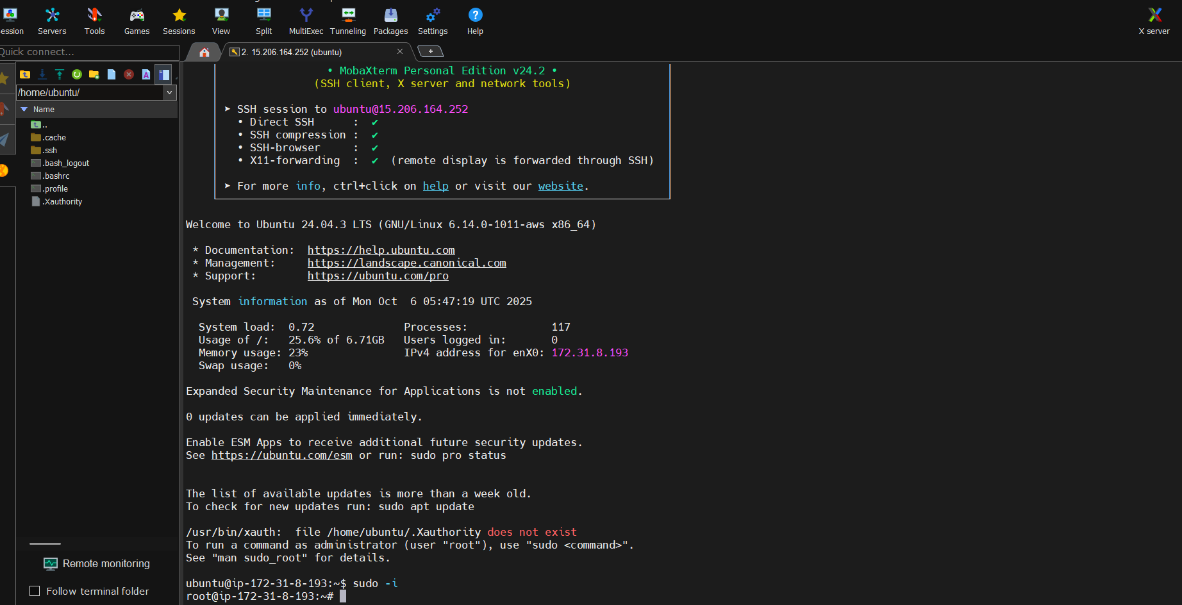

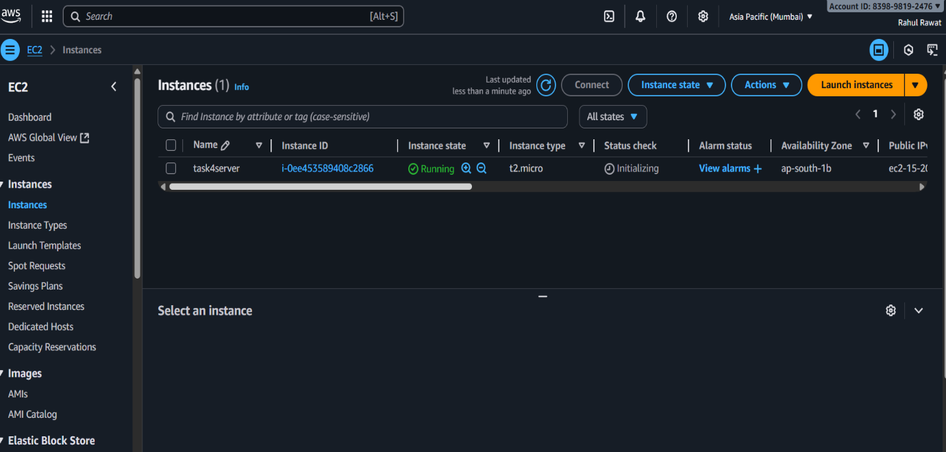

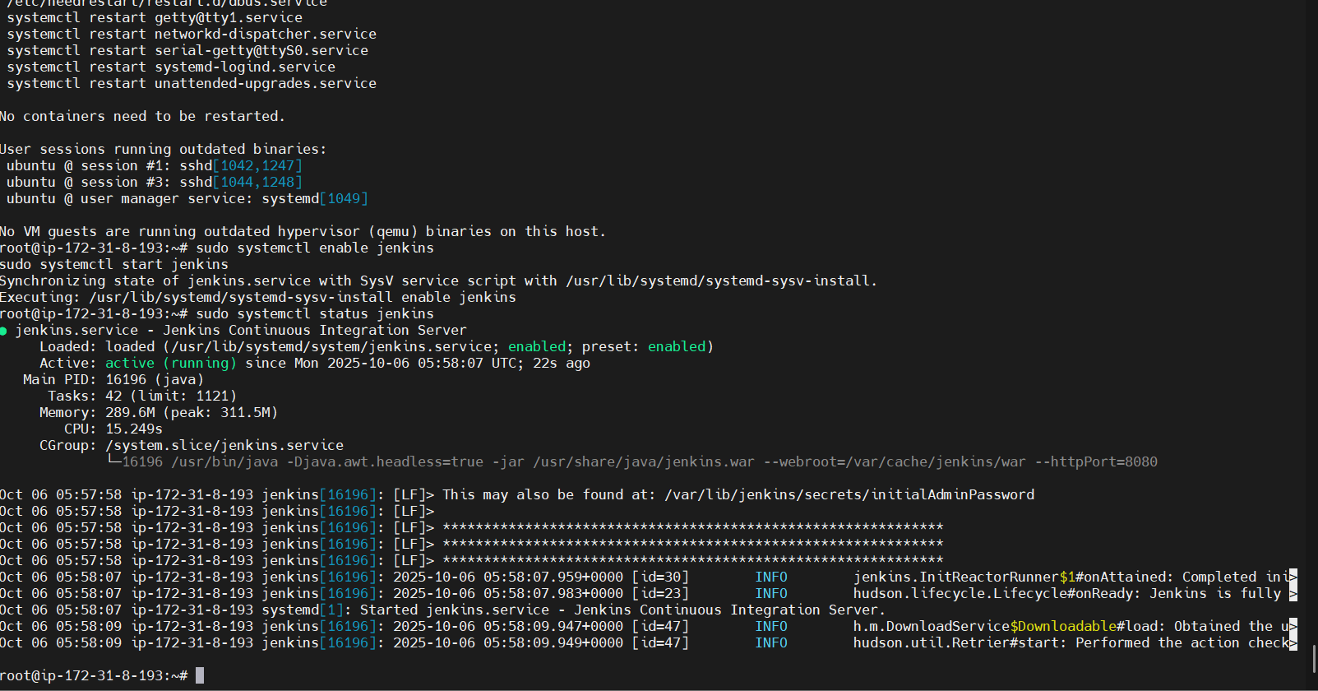

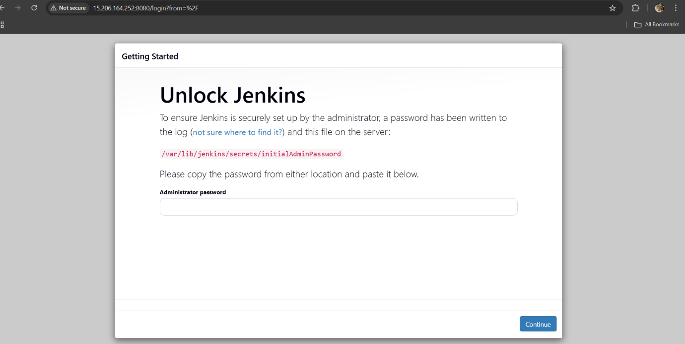



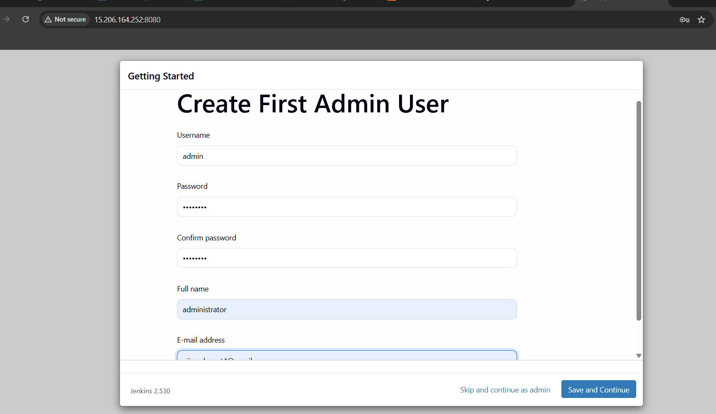

**🔐 Step 2: Connect Jenkins with GitHub**

1. Create **Personal Access Token (PAT)** on GitHub
   * Go to *Settings → Developer Settings → Personal Access Tokens → Tokens (classic)*
   * Give scopes: repo, admin:repo_hook
2. In Jenkins:
   * Go to **Manage Jenkins → Credentials → Add Credentials**
   * Kind: Secret Text
   * Secret: (Paste PAT)
   * ID: github-creds

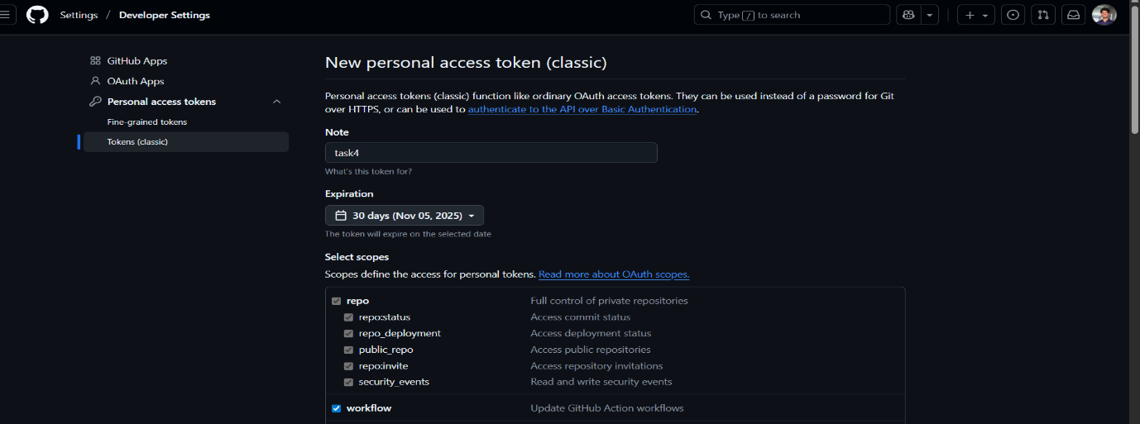

**🧱 Step 3: Create New Jenkins Pipeline**

1. Dashboard → **New Item → Pipeline → OK**
2. Scroll down → Under *Pipeline*, select:
   * Definition: *Pipeline script from SCM*
   * SCM: *Git*
   * Repository URL:
   * https://github.com/Ujjawal17-alt/project-github_autobuild.git
   * Credentials: github-creds
   * Branch: main
3. Check ✅ **GitHub hook trigger for GITScm polling**
4. 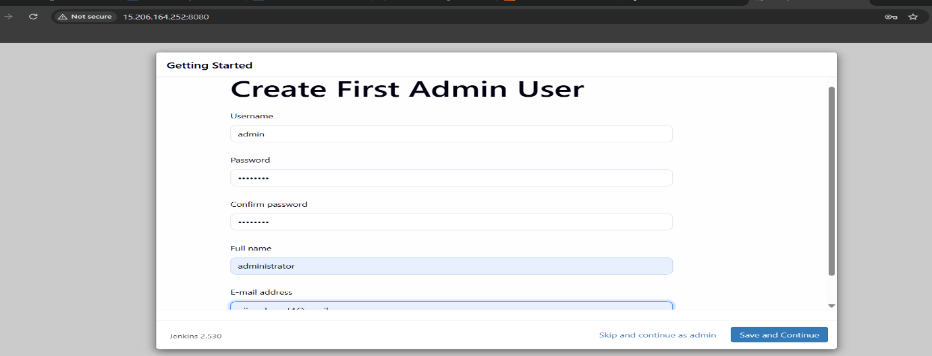Save.

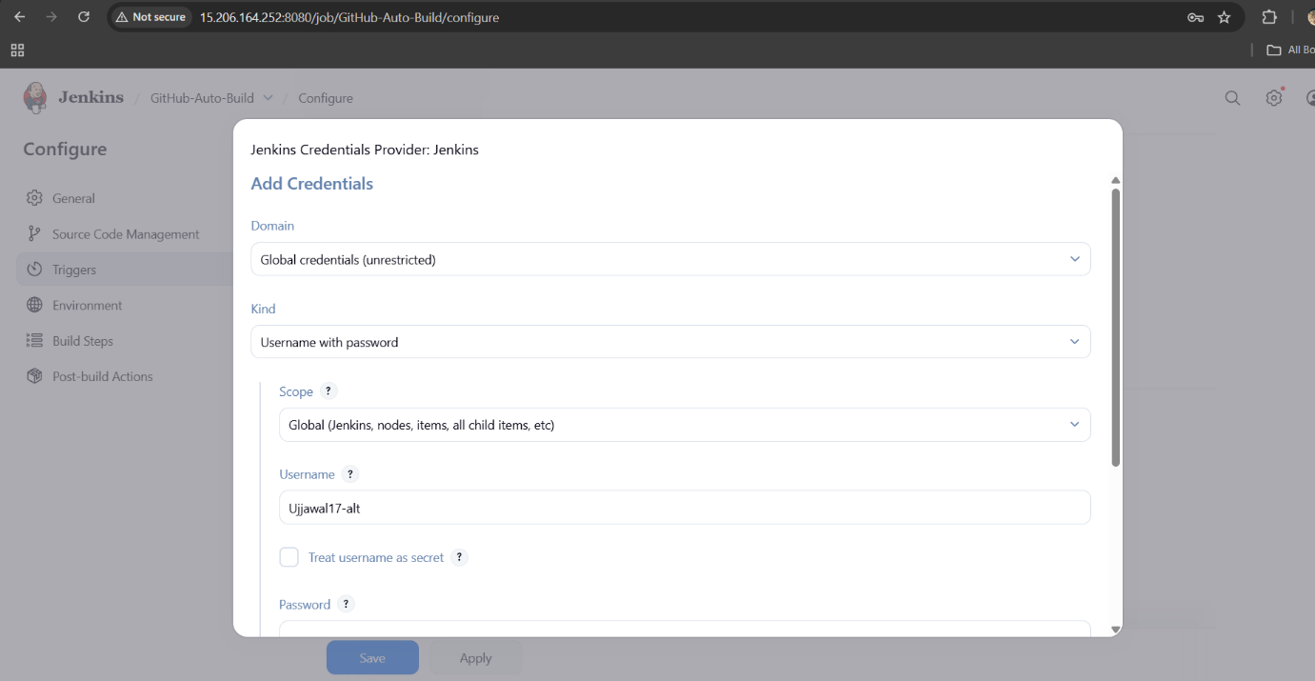

**🔗 Step 5: Configure GitHub Webhook**

1. Open your repo → **Settings → Webhooks → Add Webhook**
2. Payload URL:
3. http://<Your-Jenkins-Public-IP>:8080/github-webhook/
4. Content type: application/json
5. Trigger: ✅ *Just the push event*
6. Click **Add Webhook**

**🧪 Step 6: Test the Automation**

Make a small code change to trigger the pipeline:

echo "Testing Jenkins Webhook Integration" >> README.md

git add README.md

git commit -m "Webhook test successful"

git push origin main

* Time Taken: **4.1 sec**
* Revision ID: 1c02e9b21be64ec7bb5c22205c52fb255d3ab772
* 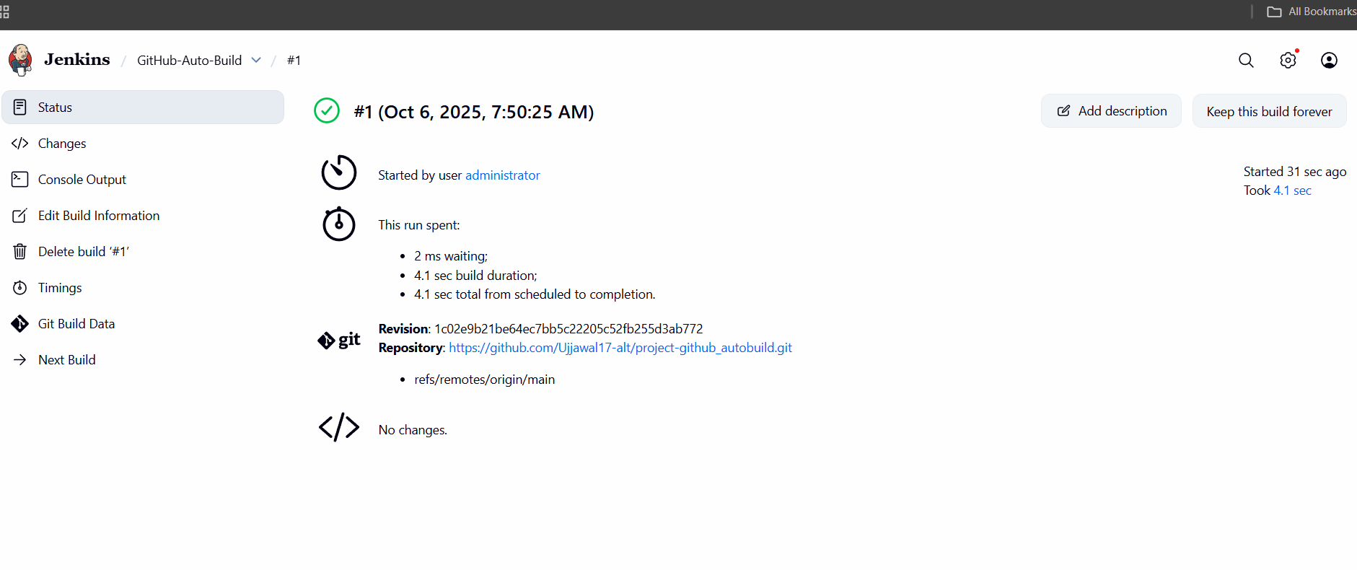Repository:  
  🔗 [GitHub Repo](https://github.com/Ujjawal17-alt/project-github_autobuild.git)

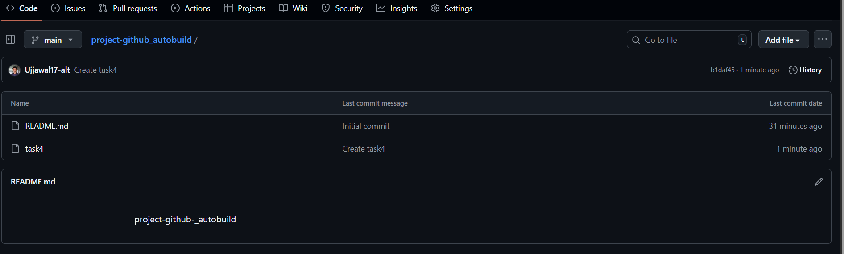

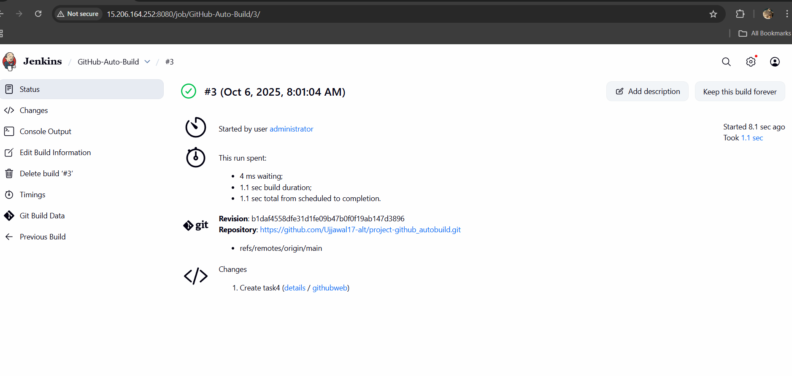

* ✅ GitHub integrated with Jenkins using PAT
* ✅ Jenkins automatically built Docker image
* ✅ Docker image pushed to Docker Hub
* ✅ Webhook trigger confirmed successful